**SUPPLEMENTAL MATERIALS**

***Empathic and Numerate Giving: The Joint Effects of Images and Charity Evaluations***

**Additional Method Information**

**Overview of study methods**

|  |  |  |  |  |  |  |  |
| --- | --- | --- | --- | --- | --- | --- | --- |
| **Study** | **N** | **Base $/£** | **Bonus/ raffle?** | **Charity(s)** | **Image manipulation** | **Efficiency/effectiveness info manipulation(s)** | **Commitment**  **placement a** |
| 1 | 398 | $1.50 | $3 | Syria Fund of Save the Children | Named boy in ambulance following airstrike vs. no image | Charity Navigator (CN) positive efficiency evaluations | Commitment question asked between image and efficiency information in the combined condition. |
| 2 | 614 | $1.50 | $3 | Syria Fund of Save the Children | Named boy in ambulance… | CN pos. efficiency vs. no info vs.  negative info manip. (aid convoy not reaching destination) | Commitment to donate consistently after both image and efficiency information |
| 3 | 611 | $1.50 | 1/25 odds for $50 | Syria Fund of Save the Children | Named boy in ambulance… | CN pos. efficiency vs. no info vs.  negative info manip. (aid convoy not reaching destination) | Commitment question asked between image and efficiency information in the combined condition. |
| 4 | 608 | $2 | 1/100 odds for $50 | Syria, 2 un-named charities (choice) | Named boy in ambulance… | Conjoint eval. of 2 charities, CN efficiency (high/low) | Placement of commitment experimentally varied to be before vs after efficiency information. |
| 5 | 433 | $1.50 | $5 | Polio Eradication Initiative | Child with polio in hospital (un-named) vs. no image | Costs/ benefit anal. for Polio Eradication (favorable) | Commitment question asked between image and efficiency information in the combined condition. |
| 6 | 378 | 0 | 1/20 odds for £50 | River-blindness or Guide dogs (choice) | Blind 12-yo girl picture (unnamed) vs. no image | Cost/output (dog-life/ RB med) & cost/outcome (dog-day/ avoided-blindness) | No question about commitment. |
| Note. Gray represents materials that are identical to the previous study.  a The rationale for varying the placement of the commitment was based on an hypothesis that the timing of deliberation matters for the interaction between images and efficiency or effectiveness information. In particular, we also examined the possibility that deliberation is detrimental for prosociality if it interferes with emotional reactions at the first decision stage – when prospective donors decide if they will donate at all or not – but *not* if it is introduced at second stage instead – after an initial yes/no commitment has already been made (for more details, see additional method descriptions for each study). Additional studies (not reported here, due to a different focus than the current paper) also manipulated the order of both images and effectiveness information, but they showed no systematic order effects. | | | | | | | |

**Method Details for Each Study**

**Study 1 Method Details**

**Participants.** We recruited participants from Amazon Mechanical Turk. To assure that they were somewhat naïve about psychological experimentation, participants could only take the study if they had done 100 tasks or less in the past. Further, the invitation was open only to workers who were American and who had an approval rate of 98% or above. Based on these inclusion criteria, 398 participants took part in the study. The sample size excludes participants (*n* = 40) who failed two simple attention checks (e.g., “to monitor quality, please respond with a seven for this item”). The median age of participants in the sample was 30 years (*SD* = 10.64), and 57% were women. Participants received $1.50 as a baseline payment and a bonus of $3.00, from which they could choose to donate to the Syria fund of Save the Children.

**Design, Procedure and Instruments.** Participants were invited to a study focusing on knowledge and opinions about the civil war in Syria. They were first asked about their familiarity with the civil war, and particularly a news headline stating that “U.N. Relief Official Calls Crisis in Aleppo the ‘Apex of Horror’” (Gladstone, 2016). We used this to rule out the possibility that participants in the control and efficiency conditions would simply be less aware of the problem, as compared to the image condition (i.e. establishing a baseline problem description). Subsequently, participants were randomly assigned to the experimental conditions.

The study employed a 2 (Victim image: Yes/No) × 2 (Efficiency information: Yes/No) between-subjects design. In a first (control) condition, participants were at the very onset of the study asked if they would be willing to donate part of a completion bonus ($3) to the Syria fund of Save the Children (yes/no). Proceeding to the next page, they were asked to specify an amount to give, using a slider from $0 to $3 ($0.01 increments). The instructions stated that they should leave the slider at 0 if they wished to receive the full bonus (in all studies the slider was positioned at 0 at the onset).

In the image only condition, participants were first shown a widely publicized image of an injured boy in an ambulance after an airstrike in Aleppo. A brief caption from the Guardian included the boy’s name (see Nott, 2016), hence introducing an identified victim (see also Kogut & Ritov, 2005a). Seeing the image, participants were asked to report their spontaneous reaction, writing down the first word that came to mind (responses indicated the anticipated emotional responses, such as “sad,” “devastated,” and “horrified”). After providing their reactions, participants answered the same donation questions as in the control condition.

In the efficiency information condition, we presented participants with ratings of Save the Children from charitynavigator.org. This website rates thousands of charities in terms of their (1) financial health and (2) accountability/transparency (Charity Navigator, 2017). The financial score provides a non-arbitrary metric of efficiency that is based on, for example, percentage of total expenses that are dedicated to the charity operations. Participants were asked if they were familiar with efficiency ratings like this, and were subsequently asked the donation questions.

In a final (combined image and efficiency) condition, participants first viewed the same image materials as described above. Next they answered the question about intent to donate (yes/no), and then they received the efficiency information. Directly following the efficiency information, we presented the question about amounts to donate.

**Study 2 Specific Rationales**

Although positive efficiency information may not increase donations in general, it is still possible that people are more responsive to negative efficiency. We tested this notion in light of news reports that aid convoys to Syria were suspended as a result of attacks on a relief shipment (e.g., Cunningham, DeYoung, & Roth, 2016). This would, at least temporarily, imply that donations would not be going to the intended program (i.e. low efficiency). Thus, if people donate based on the good they could do, one would expect them to refrain from giving under these circumstances.

We used the same basic design as in Study 1, but added two new conditions: One that only presented the news of ineffectiveness, and one that combined this information with Victim imagery. Overall, the study examined positive or negative efficiency information, with or without imagery, compared to a control (and imagery only) condition. Lastly, in the conditions combining imagery and positive or negative efficiency information, we placed the efficiency manipulation right after the image. Thus, we examined if the image effect would be interrupted by efficiency information (positive or negative) presented immediately afterwards, before any initial commitment had been made to donate.

**Study 2 Method Details**

**Participants.** 614 (60% women) participants took part in the study on Amazon Mechanical Turk, using the same inclusion criteria as in Study 1. This sample size excludes participants (*n* = 55) who failed two simple attention checks (e.g., “to monitor quality, please respond with a seven for this item”). Main results including these participants are presented in the supplemental materials. The median age was 29 years (*SD* = 10.16). Participants received $1.50 as a baseline payment and a $3.00 bonus, from which they could choose to donate to the Syria fund of Save the Children.

**Design, Procedure and Instruments.** Participants were again invited to a study focusing on knowledge and opinions about the civil war in Syria. The experiment employed a 2 (Victim image: Yes/No) × 3 (Efficiency information: Negative/No information/Positive) between-subjects design. The manipulations involving imagery and positive efficiency information were identical to those in Study 1. Two new conditions were created for negative efficiency information, both using a screenshot of a news heading in the Washington Post (Cunningham et al., 2016) which stated that “U.N. suspends aid convoys in Syria after deadly attack on relief shipment.” Along with this heading, we presented an image from the same article which showed one of the attacked trucks. There were no people in this image, thus providing a more stringent control, relative to the impact of viewing an image of a human victim. In one of the two conditions, we only presented this material (inefficiency information condition). In the other new condition we first showed the image of the injured boy (as in Study 1), asked about donation commitments, and then presented the news about suspended aid (combined imagery and inefficiency condition). Directly after the manipulation, all participants were first presented with the commitment question to donate (yes/no) and subsequently the question about amounts to give (for other details, see Study 1 Procedure and Instruments).

**Study 3 Specific Rationales**

Study 3 was identical to Study 2, with two exceptions. First, we used a raffle instead of bonus payments for everyone. By offering a larger amount from which participants could donate, we hoped to reduce the number of participants donating everything (i.e. we attempted to reduce the ceiling effects in Study 1 and 2). Second, in the combined conditions (image plus positive information, and image plus negative information) we returned to placing the efficiency information after the initial commitment to donate. If the sympathetic response to imagery is robust to deliberate processing once an initial commitment has been made, but not otherwise (Study 2), then we expected a main effect of imagery here, as in Study 1.

**Study 3 Method Details**

**Participants.** 611 (58% women) participants took part in the study on Amazon Mechanical Turk, using the same inclusion criteria as in Study 1 and 2. This sample size excludes participants (*n* = 70) who failed two simple attention checks (e.g., “to monitor quality, please respond with a seven for this item”). The median age was 29 years (*SD* = 9.55). Participants received $1.50 as a baseline payment and were informed that completed surveys would be entered into a raffle for $50.00 bonuses, with 1:25 odds. They could choose to donate part of that bonus, contingent on winning, to the Syria fund of Save the Children.

**Design, Procedure and Instruments.**With one exception, the experimental design was identical to that of study 2, employing a 2 (Victim image: Yes/No) × 3 (Efficiency information: Negative/No information/Positive) between-subjectss design. The difference concerned when the efficiency information was presented: In study 2 it was consistently placed before the yes/no question about donation intentions, whereas here we placed it after the intentions question (but before the question about amounts to actually donate), whenever the image was presented initially (i.e., in the image plus negative information, and the image plus positive information). All the materials were also identical, except that we asked about donations based on prospective raffle winnings, instead of bonuses for every participant. In particular, we mentioned to participants that 1 in 25 would win $50, and we asked if they would be willing, should they win, to donate part of that sum to a Syria fund of Save the Children. They indicated their answer using a slider with $1 increments.

**Study 4 Specific Rationales**

Information is sometimes evaluated dramatically differently when presented alongside comparison information (joint evaluation) versus when it is presented on its own (separate evaluation; e.g., Hsee, Loewenstein, Blount, & Bazerman, 1999; Kahneman & Miller, 1986). More specifically, Hsee et al. (1999) suggested that some qualities are difficult to assess by themselves, but gain meaning when presented alongside some alternative. In this study, we considered the possibility that charity efficiency represents such ‘difficult-to-evaluate’ information – that it only becomes meaningful in relation to a direct comparison. Study 4 further varied whether the comparison was presented before or after an initial commitment to donate.

**Study 4 Method Details**

**Participants.** 608 (59% women) participants were recruited on Amazon Mechanical Turk, using the same inclusion criteria as in the previous study. The reported analyzes did not include participants (*n* = 49) who failed two simple attention checks (e.g., “to monitor quality, please respond with a seven for this item”). For comparison, the supplemental materials provide results from the principal (two-part) analyses with the inclusion of inattentive participants. The median age was 30 years (*SD* = 10.01). Participants received $2 as a baseline payment and they were informed that completed surveys would be entered into a raffle for $50.00 bonuses. They could choose to donate part of that bonus, contingent on winning, to one of two charities in Syria.

**Design, Procedure and Instruments.**The experiment was based on a 2 (Victim image: Yes/No) × 3 (Efficiency information comparison: Early/Late/No comparison) between-subjects design. The image manipulation was the same as in previous studies, and those who were assigned to view the image always did so before any efficiency materials. The efficiency materials involved two charity ratings from charitynavigator.org, presented side by side (see https://www.charitynavigator.org/index.cfm?bay=search.summary&orgid=8166 [2016 report], and https://www.charitynavigator.org/index.cfm?bay=search.history&orgid=4438 [2016 report]). The ratings were closely matched on accountability/transparency, but varied noticeably in terms of their financial scores (i.e. their internal efficiency of putting money toward their programs). The experimental variation concerned *when* participants reviewed these ratings.

One third of participants were randomly assigned to examine the ratings before the question about donation commitment (in the same format as before, see Study 1), and subsequently chose a charity they wanted to support, if they wanted to donate (what we call the “early efficiency comparison” condition[s]). Another one third of participants were randomly assigned to a condition in which they were asked about donation commitments before reviewing the two efficiency ratings and choosing a charity to support, if any (late efficiency comparison condition[s]). A final third of participants never reviewed any efficiency ratings (no comparison condition). All participants were subsequently asked to specify an amount to donate, in case they won a raffle for $50 (1:100 odds in this study).

**Study 5 Specific Rationales**

The last two studies examined charity efficiency the way effective altruists typically do – that is, whether money spent leads to a quantifiable positive outcome. In particular, we manipulated information evaluating the effectiveness of the Polio Eradication Initiative, taking advantage of its well-monitored results as well as estimated costs and benefits (Tebbens et al., 2010). In other words, we examined a charitable cause that has been extensively evaluated in terms of its outcomes and for which it is also possible to manipulate information about whether the money put towards achieving those outcomes.

**Study 5 Method Details**

**Participants.** 433 (58% women) participants took part in the study on Amazon Mechanical Turk, based on the previously described inclusion criteria (see Study 1 methods). This sample size excludes participants (*n* = 22) who failed a simple attention check (“to monitor quality, please respond with a five for this item”). The median age was 29 years (*SD* = 10.19). Participants received $1.50 as a baseline payment and a $5.00 bonus, from which they could choose to donate to the Polio Eradication Initiative.

**Design, Procedure and Instruments.** Participants were invited to a study focusing on knowledge and opinions about polio. The experiment was based on a 2 (Victim image: Yes/No) × 2 (Effectiveness information: Yes/No) between-subjects design. For the image manipulation we used an image from the Rotary foundation with a young paralyzed girl with polio (https://www.flickr.com/photos/91311153@N02/8290596191).

The effectiveness information was manipulated within a brief fact sheet (~ 400 words) with questions and answers about polio, based on information from the Polio Eradication Initiative (2016) and the World Health Organization (2016). This manipulation is shown in full on page X and Y in these supplementary materials. Participants further answered a dozen factual and attitudinal questions about polio (e.g., which age group that is primarily affected by polio, as well as whether they think polio receives too much or too little attention in the media). Participants indicated whether they would be willing to make a donation from a $5 bonus. Only those who said yes were shown the question about amounts (as compared to study 1-4 where everyone saw the amount question).

**Study 6 Specific Rationales**

Like study 5, the final experiment focused on manipulating effectiveness information, but in this case using a conjoint evaluation of two charities dealing with blindness. This comparison was inspired by an example given by Singer (2015) discussing the cost effectiveness of treating river blindness versus providing guide dogs to blind individuals. This study was also run in in a college student sample in the United Kingdom, instead of Mturk workers in the United States. This study was pre-registered, see AAAAA.

**Study 6 Method Details**

**Participants.** We sampled 319 participants (64% women) from a large university in the United Kingdom, across a wide range of study disciplines. The median age was 29 years (*SD* = 10.19). This sample size excludes participants (*n* = 59) who could not recall a central piece of information in the text where we manipulated effectiveness information (the regions where the river blindness charity is operating). Results with inattentive participants included are presented in these supplementary materials (see p. X).

Participants in this study did not receive an individual baseline payment. Instead, they all entered into a raffle for a £50 Amazon gift card. Participants could choose to reduce their prospective gift card amount by donating to one of the two described charities for blind individuals (see procedure and instruments from more details).

**Design, Procedure and Instruments.** The experiment was based on a 2 (Victim image: Yes/No) × 2 (Effectiveness comparison: Yes/No) between-subjects design. The manipulations were embedded at the end of a survey asking about various values, attitudes, and social perceptions (e.g., Schwartz values, authoritarianism, and political ideology). The median completion time for the full study was approximately 20 minutes. The initial survey materials also had two versions, dealing with AA versus BB. The experimental manipulations for the purpose of this study was blocked on AA, BB, and CC, to counteract possible confounds introduced by the previously evaluated materials.

For the image and effectiveness manipulations, participants were first reminded that they had the chance to win a £50 gift card. They were subsequently told that they could choose to donate some, or all, of the prospective prize to help blind individuals. They were further informed that their donations would be matched, such that every £1 they would donate we would add an additional 25p. Next they received a brief problem description for blindness (similar to the initial descriptions in the previous studies, assuring that all conditions would have a baseline understanding of the problems targeted with the donations).

For the image manipulation, we used a picture of a 12-year old girl with corneal blindness (see https://www.flickr.com/photos/communityeyehealth/5492473278). We choose a picture with a neutral background setting, to make it more ambiguous what caused her blindness and what kind of help she might benefit the most from. After the image manipulation, we introduced participants to the two charities they could support – river blindness treatments or guide dogs – along with a brief description of each. Critically, we varied whether this information contained information about cost effectiveness or not. This manipulation is presented in full on page X in these supplementary materials. Participants then choose one charity to support (or neither) and then proceeded to the question about how much to give (closely mimicking the format from the previous studies.

**Donation questions**

In all studies, except the last one, participants were asked if they would be willing to donate (yes/no) before being asked about amounts to donate. For each study, participants in all conditions were asked the same questions. The studies varied in terms of whether donations were made from a bonus (study 1,2, and 5) or prospective raffle winnings (study 3,4, and 6). The amounts and odds of winning the raffle also varied, as well as the particular cause the participants could support (see manuscript for more information).

Below is an example from study 3.

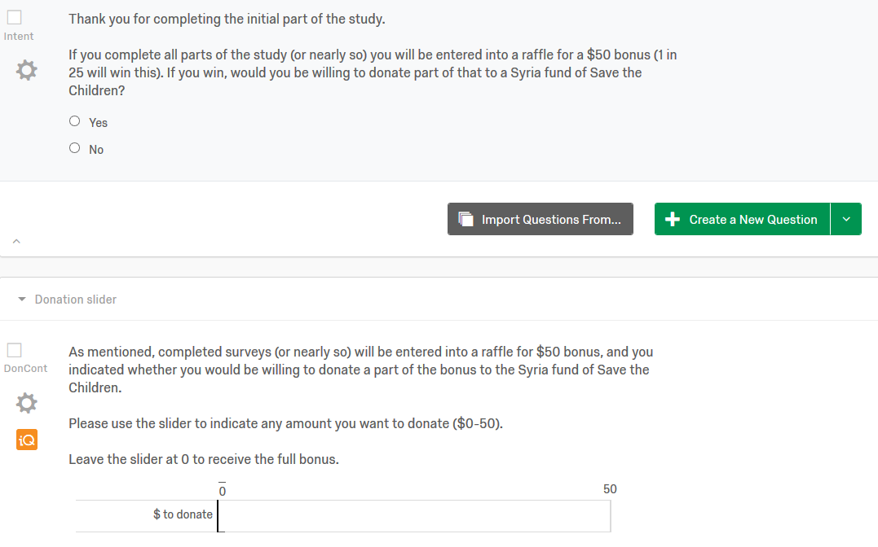

**Example of Efficiency Manipulation**

**(From Study 4, conjoint evaluation)**

There are several international charities operating in Syria, and here you some find information about two of them, from an organization rating charities in terms of efficiency. Please review this information for a moment, before you move on to the next question.  
  
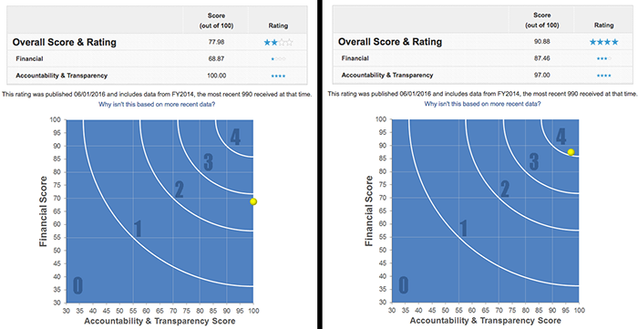

**Effectiveness manipulation, Study 5**

**(grey introductory text is the same as in the control condition)**

**What is polio?**

Poliomyelitis (polio) is a highly infectious disease caused by the polio virus. It invades the nervous system, and can cause paralysis or even death in a matter of hours.

**Who is at risk of catching polio?**

Polio mainly affects children under 5 years of age.

**What are the effects of polio?**

One in every 200 persons infected with polio leads to irreversible paralysis (usually in the legs). Among those paralysed, 5-10% die when their breathing muscles are immobilized by the virus.

**Is there a cure for polio?**

Once contracted there is no cure for polio. However, polio can be prevented by immunization. A safe and effective vaccine exists - the oral polio vaccine (OPV). Given multiple times, it protects a child for life. One dose of OPV can cost as little as 14 US cents.

**Why is so much focus placed on polio, but not on other diseases?**

Polio is one of only a few diseases which can be completely eradicated, such as was the case with smallpox. There are 3 strains of wild poliovirus, none of which can survive for long periods outside of the human body. If the virus cannot find an unvaccinated person to infect, it will die out. Polio eradication infrastructures are also used for the provision of other health services such as deworming tablets, vitamin A and bednets.  
  
**How far have we come in the process of eradicating polio?**  
In 1988, when the Global Polio Eradication Initiative was formed, polio paralysed more than 350,000 people a year. In 2013, only 416 polio cases reported. We are 99% of the way to eradicating polio globally. The world can be freed of the threat of polio - with everyone's commitment to overcome the last 1%.

**Is the quest to eradicate polio worth all the money invested in it?**

Yes, at least according to economists evaluating these efforts. The following is part of a summary from a scientific paper examining that very question:

"We estimate incremental net benefits of the GPEI [global polio eradication initiative] between 1988 and 2035 of approximately 40–50 billion dollars (2008 US dollars; 1988 net present values). […] The total economic costs saved per prevented paralytic poliomyelitis case drive the incremental net benefits […] This study finds a strong economic justification for the GPEI despite the rising costs of the initiative”.

**Control condition, Study 5**

**What is polio?**

Poliomyelitis (polio) is a highly infectious disease caused by the polio virus. It invades the nervous system, and can cause paralysis or even death in a matter of hours.

**Who is at risk of catching polio?**

Polio mainly affects children under 5 years of age.

**What are the effects of polio?**

One in every 200 persons infected with polio leads to irreversible paralysis (usually in the legs). Among those paralysed, 5%-10% die when their breathing muscles are immobilized by the virus.

**Is there a cure for polio?**

Once contracted there is no cure for polio.

**How does Polio spread?**

Polio is spread through person-to-person contact. When a child is infected with wild poliovirus, the virus enters the body through the mouth and multiplies in the intestine. It is then shed into the environment through the faeces where it can spread rapidly through a community, especially in situations of poor hygiene and sanitation.

Young children who are not yet toilet-trained are a ready source of transmission, regardless of their environment. Polio can be spread when food or drink is contaminated by faeces. There is also evidence that flies can passively transfer poliovirus from faeces to food.  
  
Even symptomless people carry the virus in their intestines and can “silently” spread the infection to thousands of others before the first case of polio paralysis emerges. For this reason, WHO considers a single confirmed case of polio paralysis to be evidence of an epidemic – particularly in countries where very few cases occur.

**What are the standards for detecting a circulation of poliovirus?**

Among other things, all acute flaccid paralysis (AFP) cases under 15 years of age or with paralytic illness at an age where polio is suspected should be reported immediately and investigated within 48 hours, and two stool specimens should be collected 24-48 hours apart and within 14 days of the onset of paralysis.

**What can be done in terms of basic hygiene to avoid polio?**

Wash your hands often. If soap and water aren’t available, clean hands with hand sanitizer (containing at least 60% alcohol). Don’t touch your eyes, nose, or mouth. If you need to touch your face, make sure your hands are clean.

# **Effectiveness and Image manipulations, Study 6**

**Below we display the image treatment from Study 6, as well as the screen containing the Effectiveness Information treatment (along with the donation choice/commitment), followed by the donation amount slider). Further implementation and design details can be found on our OSF preregistration (**<https://osf.io/pjm5n/>, <https://osf.io/pjm5n/registrations>, and at [this link (reveal.js slides](https://daaronr.github.io/dualprocess/SPI_EA_impact.html#/essex-piggyback)).

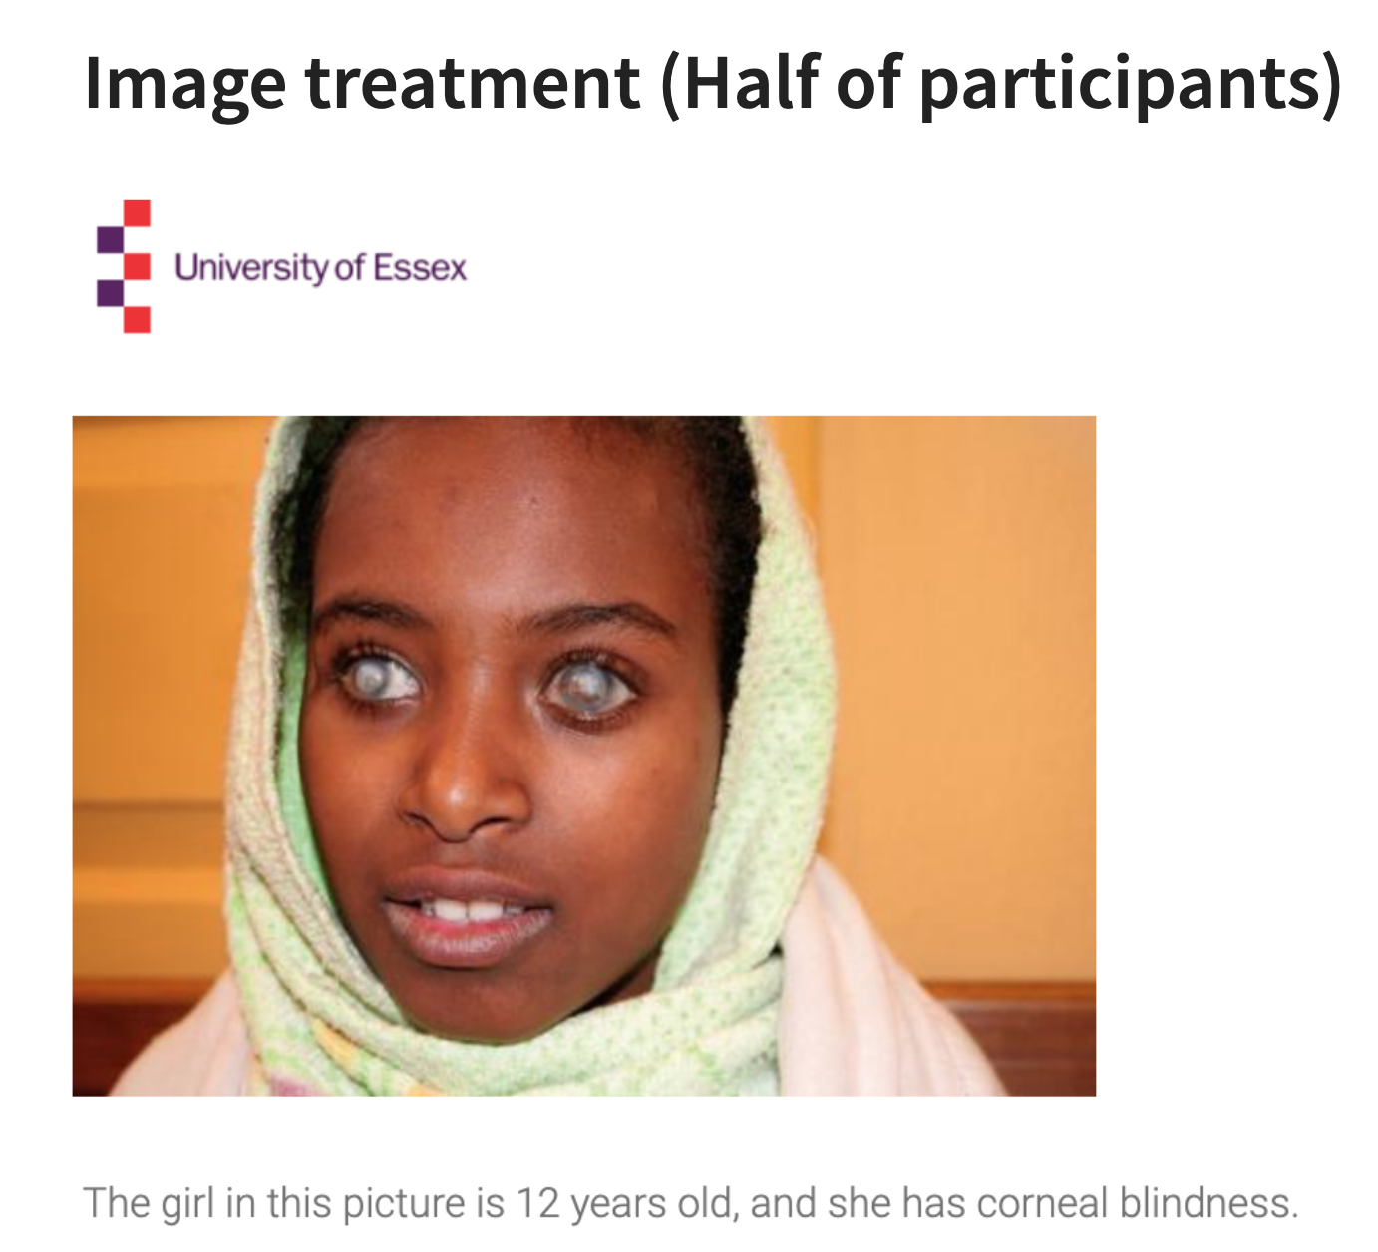

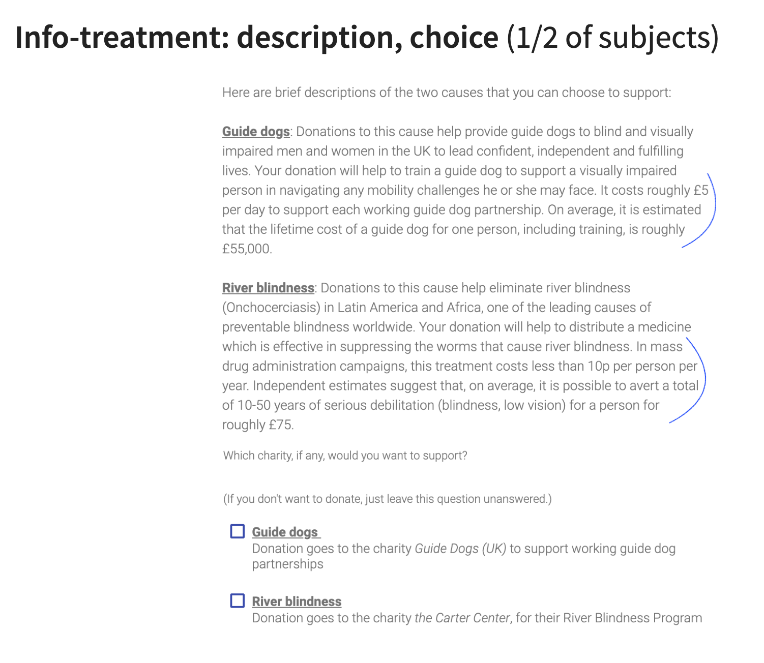

The Control screen was similar, but the last two sentences of each paragraph (indicated above in blue pen; starting with ‘It costs roughly £5 per day’ and with ‘In mass drug administration campaigns’) were not shown in the Control versions.

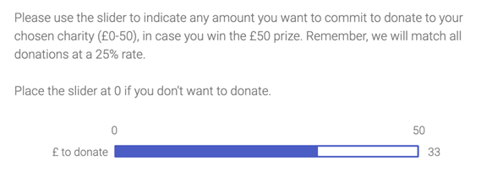

**Additional Results**

**Results including inattentive participants**

We also reran the analyses based on data from all participants who completed any of the measures in the study (i.e. including the participants who failed the attention checks).

**Study 1**

*Table S1.* Regression coefficients for experimental manipulations in Study 1 (*N* = 438).

|  |  |  |  |  |  |  |  |  |  |
| --- | --- | --- | --- | --- | --- | --- | --- | --- | --- |
| **Unstandardized results** | | | | | | | | | |
|  | **DONATE: NO (0) / YES (1)** | | |  | | **DONATED (NON-ZERO) AMOUNTS** | | | |
|  | ***B*** | **S.E.** | ***P*** | |  | | ***B*** | **S.E.** | ***p*** |
| EFF05 | -0.190 | 0.200 | 0.343 | |  | | 0.089 | 0.117 | 0.445 |
| IM05 | 0.406 | 0.200 | 0.042 | |  | | 0.203 | 0.117 | 0.082 |
| IMXEFF | -0.242 | 0.400 | 0.545 | |  | | -0.325 | 0.233 | 0.164 |

*Note*. EFF05 = Efficiency information manipulation (effect coded: +/-0.5), IM05 = Image manipulation (effect coded: +/-0.5), IMXEFF = Image × Efficiency information.

**Study 2**

*Table S2.* Regression coefficients for experimental manipulations in study 2 (*N* = 668).

|  |  |  |  |  |  |  |  |  |  |
| --- | --- | --- | --- | --- | --- | --- | --- | --- | --- |
|  | **DONATE: NO (0) / YES (1)** | | |  | | **DONATED (NON-ZERO) AMOUNTS** | | | |
|  | ***B*** | **S.E.** | ***p*** | |  | | ***B*** | **S.E.** | ***p*** |
| EFF105 | -0.175 | 0.226 | 0.441 | |  | | 0.026 | 0.128 | 0.840 |
| EFF205 | -0.182 | 0.227 | 0.423 | |  | | 0.014 | 0.132 | 0.915 |
| IM05 | 0.129 | 0.161 | 0.423 | |  | | 0.118 | 0.090 | 0.189 |
| IMXEFF | 0.137 | 0.453 | 0.762 | |  | | -0.527 | 0.257 | 0.040 |
| IMXEFF2 | 0.095 | 0.454 | 0.835 | |  | | -0.306 | 0.263 | 0.245 |

*Note.* EFF105 = Positive efficiency information manipulation (effect coded: +/-0.5), EFF205 = Negative efficiency information manipulation (effect coded: +/-0.5), IM05 = Imagery manipulation (effect coded: +/-0.5), IMXEFF = Imagery × Positive efficiency information, IMXEFF2 = Imagery × Negative efficiency information.

**Study 3**

*Table S3.* Regression coefficients for experimental manipulations in study 3 (*N* = 681).

|  |  |  |  |  |  |  |  |  |  |
| --- | --- | --- | --- | --- | --- | --- | --- | --- | --- |
|  | **DONATE: NO (0) / YES (1)** | | |  | | **DONATED (NON-ZERO) AMOUNTS** | | | |
|  | ***B*** | **S.E.** | ***p*** | |  | | ***B*** | **S.E.** | ***p*** |
| EFF105 | -0.304 | 0.261 | 0.245 | |  | | 1.106 | 1.880 | 0.556 |
| EFF205 | -0.054 | 0.268 | 0.839 | |  | | -1.473 | 1.787 | 0.410 |
| IM05 | 0.207 | 0.190 | 0.276 | |  | | 2.837 | 1.295 | 0.028 |
| IMXEFF | -0.151 | 0.523 | 0.773 | |  | | -0.344 | 3.760 | 0.927 |
| IMXEFF2 | 0.488 | 0.535 | 0.362 | |  | | -0.557 | 3.575 | 0.876 |

*Note.* EFF105 = Positive efficiency information manipulation (effect coded: +/-0.5), EFF205 = Negative efficiency information manipulation (effect coded: +/-0.5), IM05 = Imagery manipulation (effect coded: +/-0.5), IMXEFF = Imagery × Positive efficiency information, IMXEFF2 = Imagery × Negative efficiency information.

**Study 4**

*Table S4.* Regression coefficients for experimental manipulations in study 4 (*N* = 657).

|  |  |  |  |  |  |  |  |  |  |
| --- | --- | --- | --- | --- | --- | --- | --- | --- | --- |
|  | **DONATE: NO (0) / YES (1)** | | |  | | **DONATED (NON-ZERO) AMOUNTS** | | | |
|  | ***B*** | **S.E.** | ***p*** | |  | | ***B*** | **S.E.** | ***p*** |
| EFFI05 | 0.182 | 0.277 | 0.512 | |  | | -2.435 | 1.742 | 0.162 |
| EFFA05 | -0.327 | 0.268 | 0.221 | |  | | -0.274 | 1.853 | 0.883 |
| IM05 | 0.234 | 0.193 | 0.225 | |  | | 4.383 | 1.276 | 0.001 |
| IMXEFFI | 0.706 | 0.554 | 0.203 | |  | | -5.431 | 3.484 | 0.119 |
| IMXEFFA | -0.464 | 0.535 | 0.386 | |  | | 0.819 | 3.707 | 0.825 |

*Note.* EFFI05 = Early efficiency comparison (effect coded: +/-0.5), EFFA05 = Late efficiency comparison (effect coded: +/-0.5), IM05 = Imagery manipulation (effect coded: +/-0.5), IMXEFFA = Imagery × Late efficiency comparison, IMXEFFI = Imagery × Early efficiency comparison

**Study 5**

*Table S5.* Regression coefficients for experimental manipulations in Study 5 (*N* = 455).

|  |  |  |  |  |  |  |  |  |  |
| --- | --- | --- | --- | --- | --- | --- | --- | --- | --- |
|  | **DONATE: NO (0) / YES (1)** | | |  | | **DONATED (NON-ZERO) AMOUNTS** | | | |
|  | ***B*** | **S.E.** | ***p*** | |  | | ***B*** | **S.E.** | ***p*** |
| EFF05 | -0.010 | 0.191 | 0.959 | |  | | 0.116 | 0.196 | 0.552 |
| IM05 | 0.515 | 0.191 | 0.007 | |  | | 0.077 | 0.196 | 0.693 |
| IMXEFF | 0.339 | 0.381 | 0.373 | |  | | -0.540 | 0.391 | 0.167 |

*Note*. EFF05 = Efficiency information manipulation (effect coded: +/-0.5), IM05 = Imagery manipulation (effect coded: +/-0.5), IMXEFF = Imagery × Efficiency information.

**Study 6**

*Table S6.* Regression coefficients for experimental manipulations in Study 6 (*N* = 378).

|  |  |  |  |  |  |  |  |  |  |
| --- | --- | --- | --- | --- | --- | --- | --- | --- | --- |
|  | **DONATE: NO (0) / YES (1)** | | |  | | **DONATED (NON-ZERO) AMOUNTS** | | | |
|  | ***B*** | **S.E.** | ***p*** | |  | | ***B*** | **S.E.** | ***p*** |
| EFF05 | 0.021 | 0.206 | 0.920 | |  | | -1.565 | 1.984 | 0.431 |
| IM05 | -0.001 | 0.206 | 0.997 | |  | | -2.253 | 1.984 | 0.258 |
| IMXEFF | 0.212 | 0.412 | 0.607 | |  | | 3.726 | 3.968 | 0.349 |
|  |  |  |  | |  | |  |  |  |

*Note*. EFF05 = Efficiency information manipulation (effect coded: +/-0.5), IM05 = Imagery manipulation (effect coded: +/-0.5), IMXEFF = Imagery × Efficiency information.

# **Donation rates by study**

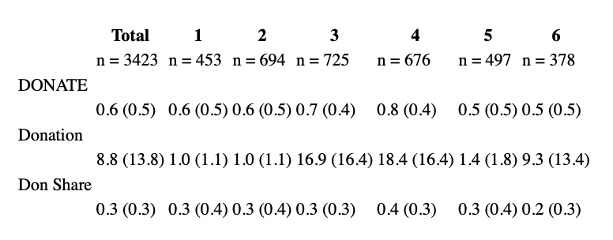

*Note*. Table reports means and standard deviations for each variable. DONATE: NO (0) / YES (1) = Dichotomous two-part outcome (Donated: Yes/no), Donation: Amounts including zeroes (in $ or £), Don Share: Share of maximum amount ($3, $3, $50, $50, $5, £50, respectively) donated

# **Conditional-on-positive Treatment effects: Lee (2009) bounded estimates**

As Lee (2009) explains, if treatments have an impact on selection into a particular *selection group*, and the composition of those selected into this *group* differs by treatment according to some *outcome*, then estimates comparing the *outcome* for treatment and control participants who are in this *selection group* will be biased. More specifically, if we compare the mean donation for treatment and control participants *throwing out all those who did not donate,* this naïve ‘conditional-on-positive’ estimate is potentially biased because, if the treatment

The “Lee-bound” procedure can recover *the impact of the treatment on the outcome, for those who would have been in the relevant ‘selected’ group whether or not they received the treatment*

under a ‘monotonicity condition’:

* + essentially, the treatment must make it either *more* or *less* likely that individuals select into the group (make a positive donation),
  + but it must not be that the treatment induces *some* individuals to select in (donate) who would not have otherwise done so, and *other* individuals to select out (not donate) who would have otherwise selected in.

Given this, the observed donors in the treatment (control) that induces a *greater likelihood of donation* would also have donated in the other treatment, but not vice-versa. To recover an asymptotically unbiased estimate of the impact of the treatment on “those who would always have donated”, an “apples to apples” comparison, we would need to “throw out” the participants in this treatment group who would not have donated under the other treatment.

Although we do not know who these “donate only in one treatment” people are, the bias will be greatest if these are the *largest* or *smallest donors.* This motivates the Lee-bound trimming procedure. The procedure amounts to “…amounts to first identifying the excess number of individuals who were induced to be selected … because of the treatment and then trimming the upper and lower tails of the outcome… distribution by this number, yielding a worst-case scenario bound.” Bounds can be further tightened by doing the above *within* groups (identified by a baseline characteristic – in our case we use the study number and the alternate treatment arm, yielding 12 cells) and taking a weighted average of these. We can tighten these further as bounds on the *average treatment effect* (those reported in bold below); the details of this are rather technical.

We report the results below for the pooled data (meta-analysis) across six studies, focusing on the amounts donated share of the maximum possible amount one could donate, and reporting results for each treatment separately.

Lee Bounds on impact of *Image* treatment on “share of maximum possible amount donated” for those who would donate a positive amount with or without the *Image* treatment

Tightened Lee (2009) treatment effect bounds

Number of obs. = 3322

Number of selected obs. = 2209

Number of cells = 12

Overall trimming proportion = 0.0786

**Effect 95% conf. interval : [-0.0172 0.1192]**

------------------------------------------------------------------------------

| Observed Bootstrap Normal-based

don_share_ | Coef. Std. Err. z P>|z| [95% Conf. Interval]

-------------+----------------------------------------------------------------

im05 |

lower | .0131366 .0184498 0.71 0.476 -.0230244 .0492975

upper | .0886843 .018538 4.78 0.000 .0523505 .125018

Lee Bounds on impact of *Effectiveness Information* treatment on “share of maximum possible amount donated” for those who would donate a positive amount with or without the *Effectiveness Information* treatment

Tightened Lee (2009) treatment effect bounds

Number of obs. = 2872

Number of selected obs. = 1896

Number of cells = 12

Overall trimming porportion = 0.0146

**Effect 95% conf. interval : [-0.0652 0.0423]**

------------------------------------------------------------------------------

| Observed Bootstrap Normal-based

don_share_~y | Coef. Std. Err. z P>|z| [95% Conf. Interval]

-------------+----------------------------------------------------------------

eff05 |

lower | -.034899 .0184408 -1.89 0.058 -.0710422 .0012442

upper | .0123167 .0182411 0.68 0.500 -.0234352 .0480687

------------------------------------------------------------------------------

The 95% confidence bounds on the CoP treatment effect of the Image include a small (-1.7%) negative and a moderate positive (11.9%) effect.

The 95% confidence bounds on the CoP treatment effect of the *Effectiveness Information* include a moderate (-5.7%) negative and a moderate positive (4.2%) effect; loosely speaking we can statistically rule out that this treatment had a large CoP effect in either direction.

Although we cannot incorporate interaction effects in this bounding estimator in a straightforward way, we present below a similar estimate of the *impact of the Effectiveness treatment in the presence of the Image treatment*, i.e., only for the set of observations where the Image treatment is present.

Lee Bounds on impact of *Effectiveness Information* in the presence of *Image Treatment* on “share of maximum possible amount donated” for those who would donate a positive amount with or without the *Effectiveness Information t*reatment

Number of obs. = 1432

Number of selected obs. = 985

Number of cells = 6

Overall trimming porportion = 0.0044

**Effect 95% conf. interval : [-0.1012 0.0062]**

------------------------------------------------------------------------------

| Observed Bootstrap Normal-based

don_share_~y | Coef. Std. Err. z P>|z| [95% Conf. Interval]

-------------+----------------------------------------------------------------

eff05 |

lower | -.0626289 .0230794 -2.71 0.007 -.1078637 -.017394

upper | -.0348458 .0245779 -1.42 0.156 -.0830176 .0133259

------------------------------------------------------------------------------

Note that the 95% confidence interval for this effect includes a fairly large (10%) negative effect and only a very small positive effect (0.6%).

# **Pooled-data regressions (meta-analysis); includes all participants**

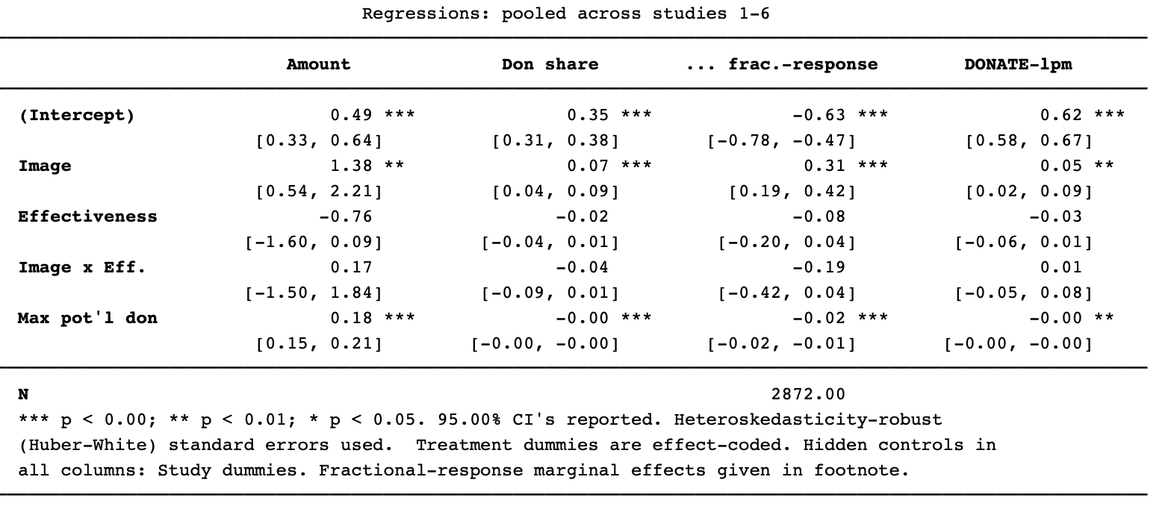

Column 1 gives an OLS regression of amount donated (including zeroes), including ‘inattentive’ participants. Columns 2-3 regress on the Share of maximum potential donation (“Max pot’l don”: $3, $3, $50, $50, $5, £50, for studies 1-6 respectively) donated. Column 2 is OLS, and column 3 is Papke-Wooldridge’s (2011) fractional response model.[1],[2] The final column presents a linear probability model of the binary “donated a positive amount” variable.

# Study 6: Impact on donations to each charity (all participants)

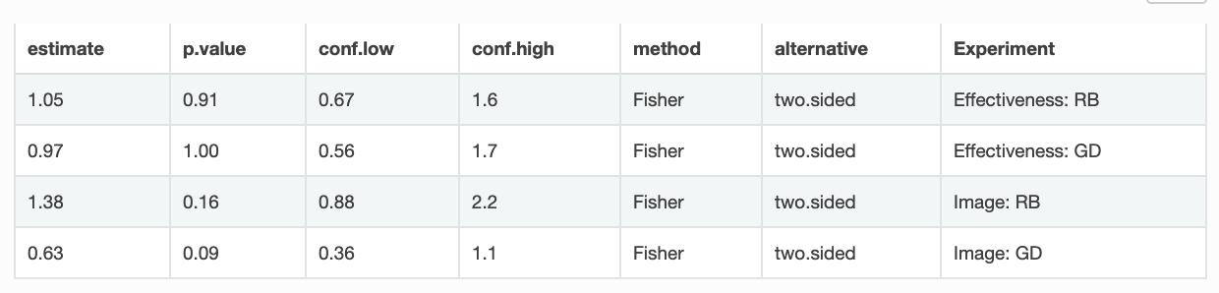

Above we see estimated of odds ratios, relative to the control group, of the incidence of donating to RB (Carter Center: the river-blindness charity) and GD (Guide Dogs for the blind). Confidence intervals reveal a lack of power. However, there is suggestive evidence (p=0.09 and p=0.16, respectively) that the image lead people to be less-likely to donate to GD and more likely to donate to RB. This may have been driven by the African appearance of the blind girl depicted.

As suggested by the box-plot below (means in red), there is also some evidence that the image treatment led to a lower *average* donation to GD (including zeroes). There is a (marginally) significant difference between the control and the Image treatment in a t-test (p=0.035) nd rank-sum test, p=0.059). (As always, all tests are two-tailed.)

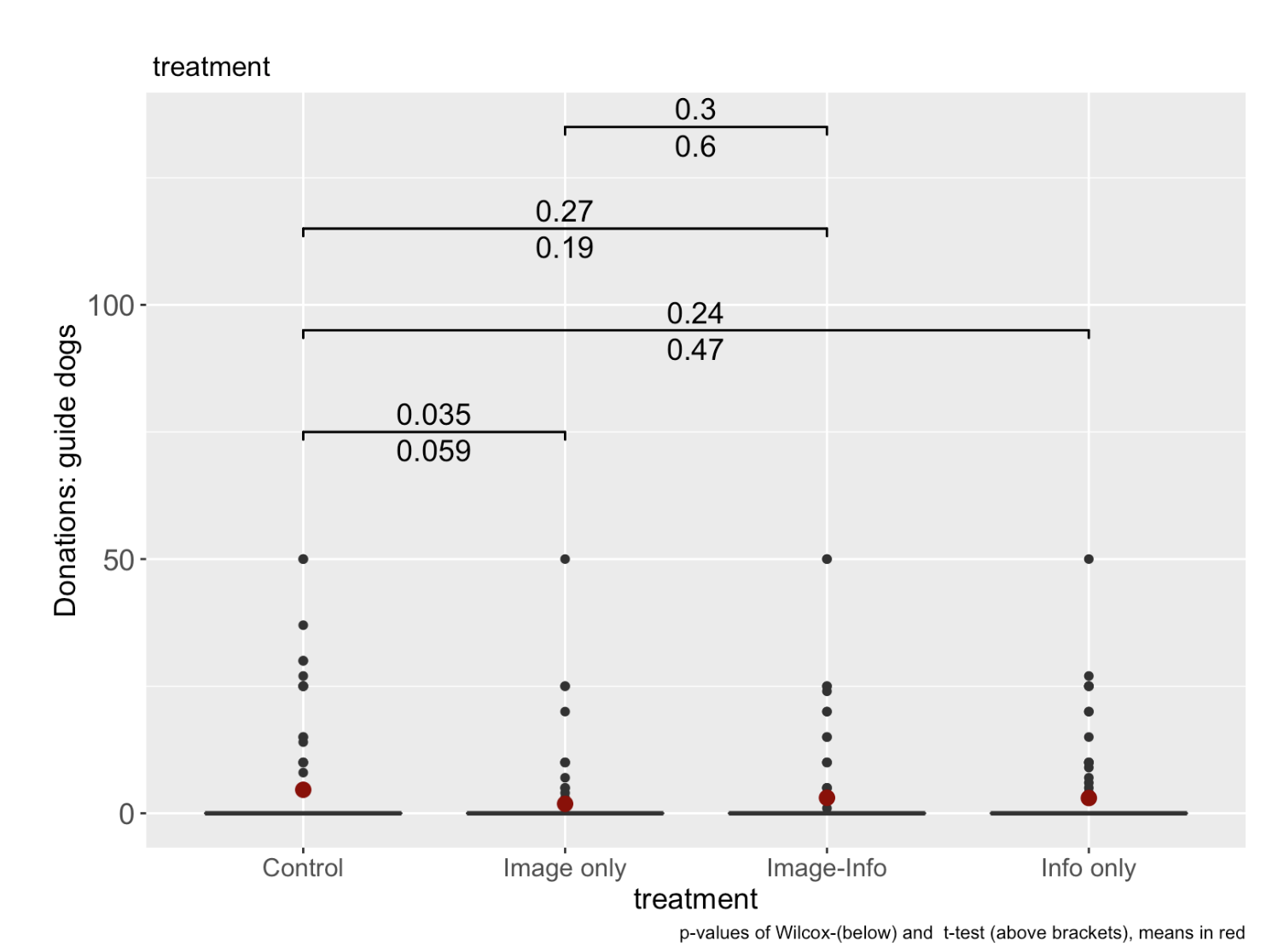

# Study 6: donation distributions (all participants)

As seen below, the distribution of donations was roughly similar across treatments.

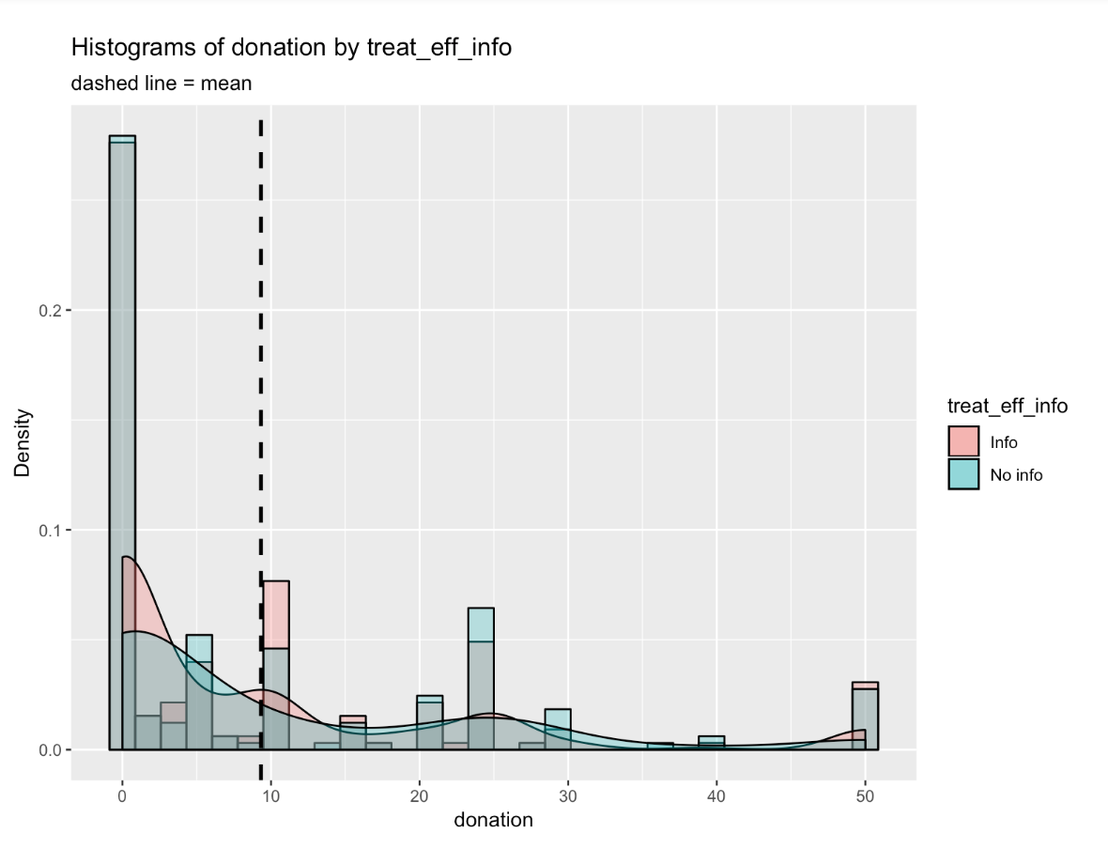

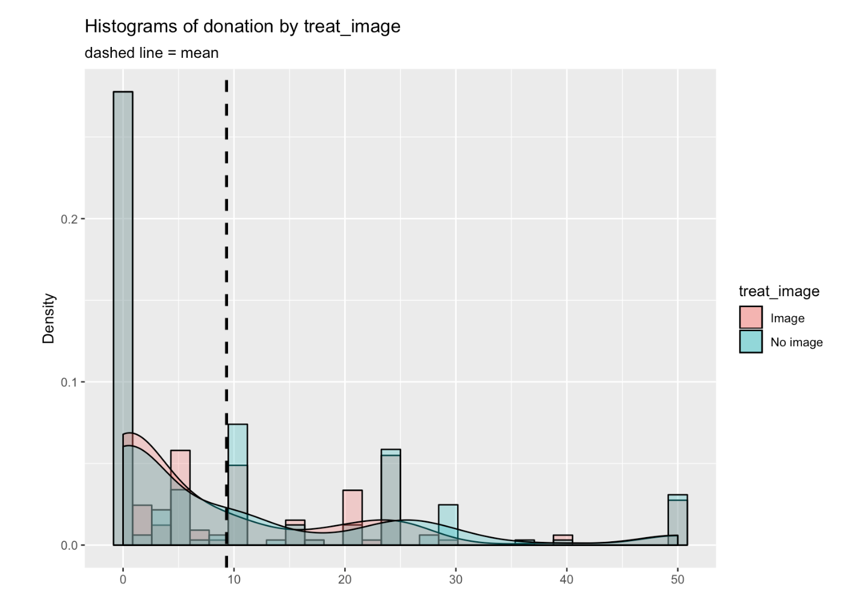

1. “Econometric Methods for Fractional Response Variables with an Application to 401 (K) Plan Participation Rates” Leslie E. Papke and Jeffrey M. Wooldridge, Journal of Applied Econometrics, Vol. 11, No. 6 (Nov. - Dec., 1996), pp. 619-632.
2. Fractional response average marginal effects: Image: 0.33, Effectiveness:, -0.08.

   0.3277 -0.07615 -0.01727 0.0296 0.9289 0.9952 -0.1844 0